Technical Report

Page1

On

FACIAL RECOGNITION

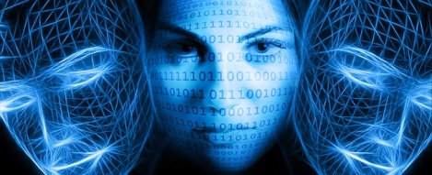

**Submitted by**

TANUSREE GAUTAM-25300117011

Page2

TABLE OF CONTENTS

Introduction 3

Why face recognition? 5

History… 6

Techniques for face acquisition 7

Applications of face recognition 11

Face recognition and identification in all walks of life 10

Benefits of facial recognition time tracking solutions 15

Understanding face recognition software 15

Limits of facial recognition time tracking solutions 17

How to overcome limits on facial recognition tools 18

Conclusion and future scope 20

INTRODUCTION

Page3

Facial recognition is a category of [biometric](https://searchsecurity.techtarget.com/definition/biometrics) software that maps an individual's facial features mathematically and stores the data as a face print. The software uses deep learning algorithms to compare a [live capture](https://searchsecurity.techtarget.com/definition/live-capture) or digital image to the stored face print in order to verify an individual's identity.

High-quality cameras in mobile devices have made facial recognition a viable option for authentication as well as identification. Apple’s iPhone X, for

example, includes Face ID technology that lets users unlock their phones with a faceprint mapped by the phone's camera. The phone's software, which is

designed with [3-D modeling](https://whatis.techtarget.com/definition/3D-modeling) to resist being spoofed by photos or masks,

Captures and compares over 30,000 variables. As of this writing, Face ID can be

used to authenticate purchases with Apple Pay and in the iTunes Store, App

Store and iBooks Store. Apple encrypts and stores faceprint data in the cloud, but authentication takes place directly on the device.

Developers can use Amazon [Rekognition](https://searchaws.techtarget.com/definition/Amazon-Rekognition), an image analysis service that's part

of the Amazon AI suite, to add facial recognition and analysis features to an

Application. Google provides a similar capability with its Google Cloud Vision

API. The technology, which uses machine learning to detect, match and

identify faces, is being used in a wide variety of ways, including entertainment

and marketing. The Kinect [motion gaming](https://whatis.techtarget.com/definition/motion-gaming-motion-controlled-gaming) system, for example, uses facial

recognition to differentiate among players. Smart advertisements in airports

are now able to identify the gender, ethnicity and approximate age of a

passersby and target the advertisement to the person's demographic.

Facebook uses facial recognition software to tag individuals in photographs. Each time an individual is tagged in a photograph, the software stores mapping information about that person’s facial characteristics. Once enough data has been collected, the software can use that information to identify a specific individual's face when it appears in a new photograph. To protect people's privacy, a feature called Photo Review notifies the Facebook member who has been identified.

Currently, there are no laws in the United States that specifically protect an

individual's biometric data. Facial recognition systems are currently being studied or deployed for airport security and it's estimated that more than half the United States population has already had their faceprint captured.

Page4

According the Department of Homeland Security, the only way to avoid having biometric information collected when traveling internationally is to refrain from traveling. The General Data Protection Regulation (GDPR) for European Member States does address biometric data.

Why Face Recognition?

Page5

Given the requirement for determining people's identity, the obvious question is what technology is best suited to supply this information? There are many different identification technologies available, many of which have been in wide-spread commercial use for years. The most common person verification and identification methods today are Password/PIN (Personal Identification Number) systems, and Token systems (such as your driver's license). Because such systems have trouble with forgery, theft, and lapses in users' memory, there has developed considerable interest in biometric identification systems, which use pattern recognition techniques to identify people using their physiological characteristics. Fingerprints are a classic example of a biometric; newer technologies include retina and iris recognition.

While appropriate for bank transactions and entry into secure areas, such technologies have the disadvantage that they are intrusive both physically and socially. They require the user to position their body relative to the sensor, and then pause for a second to `declare' themselves. This `pause and declare' interaction is unlikely to change because of the fine-grain spatial sensing required. Moreover, there is a `oracle-like' aspect to the interaction: since people can't recognize other people using this sort of data, these types of identification do not have a place in normal human interactions and social structures.

While the `pause and present' interaction and the oracle-like perception are useful in high-security applications (they make the systems look more accurate), they are exactly the opposite of what is required when building a store that recognizes its best customers, or an information kiosk that remembers you, or a house that knows the people who live there. Face recognition from video and voice recognition have a natural place in these next-generation smart environments -- they are unobtrusive (able to recognize at a distance without requiring a `pause and present' interaction), are usually passive (do not require generating special electro-magnetic illumination), do not restrict user movement, and are now both low-power and inexpensive.

Perhaps most important, however, is that humans identify other people by their face and voice, therefore are likely to be comfortable with systems that use face and voice recognition.

HISTORY

Page6

Facial recognition technology gained popularity in the early 1990s when the United States Department of Defense was seeking a technology that could spot criminals who furtively crossed borders. The Defense Department roped in eminent university scientists and experts in the field of facial recognition for this purpose by providing them with research financing.

Facial recognition made bold headlines in early 2001 immediately after it was first used in a public space—at Super Bowl XXXV in Tampa—by the law enforcement authorities to search for criminals and terrorists among the crowd of thousands of spectators. Soon after that, facial recognition systems were installed in other sensitive parts of the US to keep track of felonious activities.

Although facial recognition is the fastest-growing biometric technology, it also happens to be the most controversial. After the 9/11 tragedy, many people supported the use of this new technology, but as the technology made deeper inroads to our lives, many realized that it could pose a threat to individual privacy and could also potentially lead to identity theft. No matter which side of this debate you’re on, it is worth knowing how this fast-growing technology

works and what it can do.

Techniques for face acquisition

Page7

Essentially, the process of face recognition is performed in two steps. The first involves [feature extraction](https://en.wikipedia.org/wiki/Feature_extraction) and selection and, the second is the classification of objects. Later developments introduced varying technologies to the procedure. Some of the most notable include the following techniques:

* Traditional

Some face recognit[ion algorithms](https://en.wikipedia.org/wiki/Algorithms) identify facial features by extracting landmarks, or features, from an image of the subject's face. For example, an algorithm may analyze the relative position, size, and/or shape of the eyes, nose, cheekbones, and jaw. These features are then used to search for other images with matching features.

Other algorit[hms normalize](https://en.wikipedia.org/wiki/Normalization_(image_processing)) a gallery of face images and then compress the face data, only saving the data in the image that is useful for face recognition. A probe image is then compared with the face data. One of the earliest successful systemsis based on template matching techniques applied to a set of salient facial features, providing a sort of compressed face representation.

Recognition algorithms can be divided into two main approaches, geometric, which looks at distinguishing features, or photometric, which is a statistical approach that distills an image into values and compares the values with templates to eliminate variances. Some classify these algorithms into two broad categories: holistic and feature-based models. The former attempts to recognize the face in its entirety while the feature-based subdivide into components such as according to features and analyze each as well as its spatial location with respect to other features.

Popular recognition algorithms include [principal component](https://en.wikipedia.org/wiki/Principal_component_analysis) [analysis](https://en.wikipedia.org/wiki/Principal_component_analysis) using [eigenfaces](https://en.wikipedia.org/wiki/Eigenface), [linear discriminant analysis](https://en.wikipedia.org/wiki/Linear_discriminant_analysis), [elastic bunch graph](https://en.wikipedia.org/wiki/Elastic_matching) [matching](https://en.wikipedia.org/wiki/Elastic_matching) using the Fisherface algorithm, the [hidden Markov model](https://en.wikipedia.org/wiki/Hidden_Markov_model), the [multilinear subspace learning](https://en.wikipedia.org/wiki/Multilinear_subspace_learning) using [tensor](https://en.wikipedia.org/wiki/Tensor) representation, and the neuronal motivated [dynamic link matching](https://en.wikipedia.org/wiki/Dynamic_link_matching).

* 3-Dimensional recognition

[Three-dimensional face recognition](https://en.wikipedia.org/wiki/Three-dimensional_face_recognition) technique uses 3D sensors to capture information about the shape of a face. This information is then used to identify distinctive features on the surface of a face, such as the contour of the eye sockets, nose, and chin.

One advantage of 3D face recognition is that it is not affected by changes in lighting like other techniques. It can also identify a face from a range of viewing angles, including a profile view. Three-dimensional data points from a face vastly improve the precision of face recognition. 3D research is enhanced by the development of sophisticated sensors that do a better job of capturing 3D face imagery. The sensors work by projecting structured light onto the face. Up to a dozen or more of these image sensors can be placed on the same CMOS chip—each sensor captures a different part of the spectrum....

Page 8

Even a perfect 3D matching technique could be sensitive to expressions. For that goal a group at the [Technion](https://en.wikipedia.org/wiki/Technion) applied tools from [metric geometry](https://en.wikipedia.org/wiki/Metric_geometry) to treat expressions as [isometries](https://en.wikipedia.org/wiki/Isometries).

A new method is to introduce a way to capture a 3D picture by using three tracking cameras that point at different angles; one camera will be pointing at the front of the subject, second one to the side, and third one at an angle. All these cameras will work together so it can track a subject's face in real time and be able to face detect and recognize.

* Skin texture analysis

Another emerging trend uses the visual details of the skin, as captured in standard digital or scanned images. This technique, called Skin Texture Analysis, turns the unique lines, patterns, and spots apparent in a person's skin into a mathematical space.

Surface Texture Analysis works much the same way facial recognition does. A picture is taken of a patch of skin, called a [skinprint](https://en.wikipedia.org/w/index.php?title=Skinprint&amp;action=edit&amp;redlink=1). That patch is then broken up into smaller blocks. Using algorithms to turn the patch into a mathematical, measurable space, the system will then distinguish any lines, pores and the actual skin texture. It can identify the contrast between identical pairs, which are not yet possible using facial recognition software alone.

Tests have shown that with the addition of skin texture analysis, performance in recognizing faces can increase 20 to 25 percent.

* Facial recognition combining different techniques

As every method has its advantages and disadvantages, technology companies have amalgamated the traditional, 3D recognition and Skin Textual Analysis, to create recognition systems that have higher rates of success.

Combined techniques have an advantage over other systems. It is relatively insensitive to changes in expression, including blinking, frowning or smiling and

has the ability to compensate for mustache or beard growth and the appearance of eyeglasses. The system is also uniform with respect to race and gender.

Page9

* Thermal cameras

A different form of taking input data for face recognition is by using thermal cameras, by this procedure the cameras will only detect the shape of the head and it will ignore the subject accessories such as glasses, hats, or makeup. Unlike conventional cameras, thermal cameras can capture facial imagery even in low-light and nighttime conditions without using a flash and exposing the position of the camera. However, a problem with using thermal pictures for face recognition is that the databases for face recognition is limited. Diego Socolinsky and Andrea Selinger (2004) research the use of thermal face recognition in real life and operation sceneries, and at the same time build a new database of thermal face images. The research uses low-sensitive, low- resolution ferroelectric electrics sensors that are capable of acquiring longwave thermal infrared (LWIR). The results show that a fusion of LWIR and regular visual cameras has greater results in outdoor probes. Indoor results show that visual has a 97.05% accuracy, while LWIR has 93.93%, and the Fusion has 98.40%, however on the outdoor proves visual has 67.06%, LWIR 83.03%, and fusion has 89.02%. The study used 240 subjects over a period of 10 weeks to create a new database. The data was collected on sunny, rainy, and cloudy days.

In 2018, researchers from the [U.S. Army Research Laboratory (ARL)](https://en.wikipedia.org/wiki/United_States_Army_Research_Laboratory) developed a technique that would allow them to match facial imagery obtained using a thermal camera with those in databases that were captured using a conventional camera. This approach utilized [artificial intelligence](https://en.wikipedia.org/wiki/Artificial_intelligence) and [machine](https://en.wikipedia.org/wiki/Machine_learning) [learning](https://en.wikipedia.org/wiki/Machine_learning) to allow researchers to visibly compare conventional and thermal facial imagery. Known as a cross-spectrum synthesis method due to how it bridges facial recognition from two different imaging modalities, this method synthesizes a single image by analyzing multiple facial regions and details. It consists of a non-linear regression model that maps a specific thermal image into a corresponding visible facial image and an optimization issue that projects the latent projection back into the image space.

ARL scientists have noted that the approach works by combining global information (i.e. features across the entire face) with local information (i.e. features regarding the eyes, nose, and mouth). In addition to enhancing the discriminability of the synthesized image, the facial recognition system can be used to transform a thermal face signature into a refined visible image of a face. According to performance tests conducted at ARL, researchers found that

the multi-region cross-spectrum synthesis model demonstrated a performance improvement of about 30% over baseline methods and about 5% over state-of- the-art methods. It has also been tested for landmark detection for thermal images.

Page10

Facial recognition is a quickly evolving technology, and its laws and regulations need to keep up.

“Say hello to the future” the tagline of iPhoneX marked the advent of face recognition into mainstream apps using it as a feature to unlock the phone. Though this marks a milestone in itself as far as facial recognition technology is concerned; what caught my eye was the use of face id in the [sniper software](https://www.theguardian.com/science/2017/nov/13/ban-on-killer-robots-urgently-needed-say-scientists) — termed killer bots as presented at the United Nations body on autonomous weapons. It uses face identification technology to select and kill human targets.

Both sides of the coin — boon or bane — that holds true for any powerful technology and this just goes on to demonstrate how powerful face recognition could be.

Face Recognition and Identification in all Walks of Life

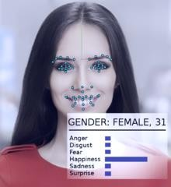

Source: Visage Technologies Ltd, Creative Commons License, Wikimedia.org

Identity management and security is the most common and visible application of this technology. We have heard of Governments keeping a database of citizen faces which can be used for law enforcement, rising albeit the critical question on an individual’s privacy. However, face recognition is now finding applications across all industries

Applications of Face Recognition

Page11

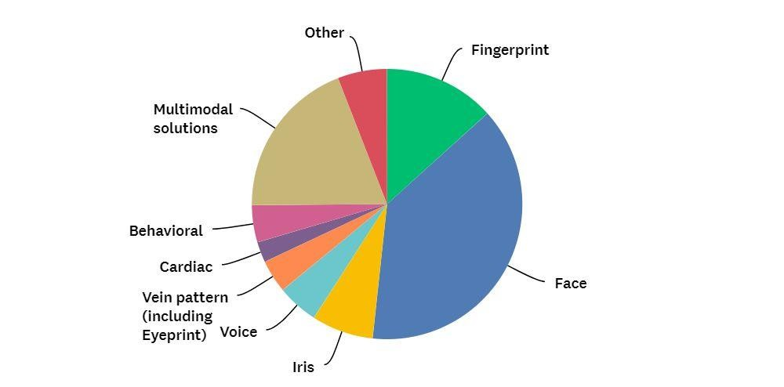

Various applications of facial recognition technology in today’s world

* **Retail** — Large retailers are using facial recognition to instantly recognize customers and present offers. They can also use it to catch shoplifters augmented with camera footage. The entertainment industry, casinos, and theme parks have also caught on to its uses. Companies like [NTechLab](http://ntechlab.com/), [Kairosuse](https://www.kairos.com/) face recognition technology to provide customer analytics.
* **Advertising** — visual intelligence is providing not just superficial identity but it’s also checking on emotions, expressions, and features to target audience

accordingly. [Gumgum](https://gumgum.com/) is a facial recognition firm that can serve targeted advertising using faces. For example, it will recognize a celebrity photograph and serve a related ad without checking on the text or content around the image. [Facebook has filed](https://www.google.com/patents/US20150242679) [patents for technology](https://www.google.com/patents/US20150242679) allowing tailoring ads based on users’ facial expressions.

* **Auto-Tech** — [Affectiva](https://www.affectiva.com/), a company which specializes in face identification for identifying of emotions, says with EmotionAI technology they are actually looking at a future car which can tell us if the driver is happy or sad.
* **Healthcare** — Analyzing faces to provide automated diagnosis of rare genetic conditions, such as Hajdu-Cheney syndrome is being explored. Recognition of expressions and emotions may give autistic people a grasp of social signals they find elusive.
* **Banking** — Bankers are now looking to introduce face recognition in [mobile apps](http://www.biometricupdate.com/201710/hsbc-introduces-facial-recognition-to-its-mobile-banking-app-in-china) and ATMs for identification. China is already seeing an application where a

customer [withdrawing money from ATMs](https://www.bloomberg.com/news/articles/2017-06-28/macau-atms-need-face-time-before-payout-to-help-follow-the-money) in Macau need to punch in their PIN and also to stare into a camera for six seconds so facial-recognition software can verify their identity and help monitor transactions.

* **Photo management Apps** are in the forefront as far as the usage of this technology. Some cameras, including the ones on the smartphones, can now display the age on every face in the picture.

Page12

These examples reveal that face recognition is no longer a gimmick, but a technology with increasing impact as it finds applications in security and law enforcement, brands and PR agencies, targeted advertising, photo management and imaging apps, shopping and retailing, banking, healthcare among others.

Understanding Face Recognition Software

Face recognition deals with Computer Vision a discipline of Artificial Intelligence

and uses techniques of image processing and deep learning. Face recognition algorithms can be further classified based on whether they are used on 2D or 3D images or on finding faces in motion, like in a video.

**Face Detection vs. Face Recognition**

Though sounding similar, the complexity involved in both is vastly different. In

Face Detection, the computer recognizes the face within an image and locates its

position. If you have used face changer app on Snapchat, you are using face

detection. Face recognition deals with identification to establish whose face it is by

matching it to an existing face database.

**Face Recognition Databases**

Face recognition databases are freely available as well as owned by companies. Here is a list of [60 facial recognition databases.](https://www.kairos.com/blog/60-facial-recognition-databases) Google’s artificial intelligence system dubbed FaceNet includes more than 13,000 pictures of faces from across the web. Trained on a massive 260-million-image dataset, FaceNet performed with better than 86 percent accuracy. Facebook supposedly has one of the largest face databases, adding a face every time a person gets tagged on Facebook.

**Face Recognition Software Features**

Apart from identification other typical features are

* Emotion Detection
* Age Detection
* Gender Detection
* Attention Measurement
* Sentiment Detection

Page13

* Ethnicity Detection
* Apprehensions about Face Recognition — Privacy and Ethics
* The underlying sensitivity with the face being a bio-metric data; raises a lot of concerns about privacy.

*A huge worry is around using this technology to identify individuals in public spaces without their knowledge or permission.*

As the ability to read faces increases, we also see a lot of challenges in terms of its applications and a thin line between what is ethical and what is not. Researchers at Stanford University have demonstrated that, when shown pictures of one gay man, and one straight man, the algorithm could attribute their sexuality correctly 81% of the time. Uses of face recognition in recruitment could allow employers to use it to filter job applications and act on their prejudices to deny a person a job.

Apart from privacy and ethics, the other concern is regarding the reliability of the technology. There is a story of how a 10-year-old was able to unlock his mother’s iPhone with his Face ID. Also, dependability of face id as a biometric is a concern when dealing with identical twins or when a face age.

The skeptics remain.

Nevertheless, this is a technology that is evolving at an ever-increasing speed and the laws and regulations around it need to keep pace. One thing is certain though if you have a digital presence on the internet; your face is no longer private; it is public property now — out there in the digital universe.

Security and Defense

By far the most popular applications of facial recognition technology has been for personal as well as public security by law enforcement agencies. Personal security includes gaining access to personal information and most popularly ***personal mobile devices***.

Even though facial recognition in mobile phones is rather minuscule in terms of levels of

sensitive information that can be accessed, biometric technology is even being used to grant people entry to government buildings, sensitive areas of offices as well as public events for security purposes.

Automotive giants Jaguar are researching biometrics to possibly feature technology that will grant a driver entry to the vehicle based upon how he/she walks towards it. Whether it turns out to be more than just a gimmick is yet to be seen.

Law enforcement, on the other hand, has been using computerized facial recognition technology and other biometric data for over two decades. Identification of felons has become more evolved as 3D facial technology has made search and apprehension of individuals more efficient.

Page14

The US Customs plan to incorporate facial recognition and biometrics into their entry/exit gates at Orlando International Airport and 12 others to collect information regarding passengers with criminal records by matching these images with the database maintained by the Department of Homeland Security. If successful, the applications of facial recognition could be applied to every airport in the country.

Retail and Marketing

The use of technology has become popular in retail outlets to ***prevent***

***shoplifting*** and ***reduce crime*** within their stores. As shoppers walk in, their faces are captured and contrasted against a database to identify people with a history of petty and violent crime alike. This type of tech is said to be able to ***reduce shoplifting by over 30%.***

Apart from this, the applications of facial recognition can be used to ***promote products*** and more accurately ***target advertisements***. At ***FaceX***, there is even the development of a smartphone app that detects the skin tone of the user and suggests skincare and cosmetic products that the user can purchase.

Through facial recognition, marketers can collect data such as ***age, gender, and ethnicity*** to more effectively target their advertisements. The easiest part is that existing surveillance cameras can be used and simply gaining access to these cameras to collect data is sufficient.

Healthcare

Possibly one of the most important Applications of Facial Recognition technology is in the healthcare sector. Doctors and healthcare officials alike can use facial recognition

to ***access patient’s medical records*** as well as ***monitor and diagnose certain diseases***.

If implemented properly, potentially fatal diseases can be diagnosed and treated early to avoid the worst outcomes. Currently, only a handful of diseases and disorders can be detected but with the evolution of the technology, it can be further enhanced to catch others as well.

Hospitality

The hospitality sector is one of the most competitive industries in the world. Every advantage whether large or small makes a difference to the players within it. By Applications of Facial Recognition technology, the possibilities are endless.

Hotels can ***record customer preferences, provide better security and automate***

***check-ins and check outs***. The reduction of human error brings a ***streamlined*** approach

to mundane customer service tasks that don’t require a touch of humanity.

You can no longer hide away but face this fact. The sooner the better!

Page15

### 5 Benefits of Facial Recognition Time Tracking Solutions

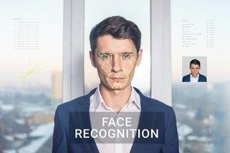

Biometric technology is becoming increasingly popular for time and attendance tracking. Although fingerprint biometrics is a popular choice, facial recognition time tracking is an alternative biometric solution with certain distinct advantages.

How Facial Recognition Time Tracking Systems Work

Facial recognition time tracking uses biometric identification verification based on facial characteristics.

[Facial recognition technology](http://www.newsweek.com/facial-recognition-facial-recognition-technology-technology-privacy-privacy-592117) varies. The system may look at specific algorithms of the distances between features, consult 2D images, or use 3D facial recognition to identify specific facial features.

The first step in implementing facial biometrics is to get all employees registered in the facial database for future identification and biometrics authentication. From that point forward, when an employee clocks in or seeks

access to a particular area, the employee’s face is scanned and biometric software identifies and authenticates based on facial recognition and the employee’s information.

Advantages of Face Recognition Time Tracking

Time tracking with facial recognition can benefit your company in a number of ways:

* + **Automated time tracking system**: Automation simplifies time tracking, and there is no need to have personnel to monitor the system 24 hours a day. To err is human, and with automated systems, human error is eliminated. A time and attendance system using facial recognition technology can accurately report attendance, absence, and overtime with an identification process that is fast as well as accurate.
  + **Labor cost savings**: Facial recognition software can accurately track time and attendance without human error. It keeps track of the exact number of hours an employee is working, which can help save the company money. You will never have to worry about time fraud or “buddy punching” with a facial recognition time tracking system.

Page16

* + **Tighter security**: Facial biometric time tracking allows you to not only track employees but also add visitors to the system so they can be tracked throughout the worksite. Access can be denied to any person not in the system. If an incident should occur, facial recognition software can provide evidence for an investigation with a scanned image of a person or persons who have entered the area.
  + **Time saving and reduced contagion**: When contagious illnesses such as colds and viruses spread throughout the workforce, it can increase the incidence of employee absences and significantly reduce productivity. With facial recognition, employees can enter and leave the facility in considerably less time. There is no need to touch the surface of the system to clock in or out. This saves time, as well as minimizing the spread illnesses due to physical contact.
  + **Ease of integration**: Biometric facial recognition technology can be easily programmed into your time and attendance system.

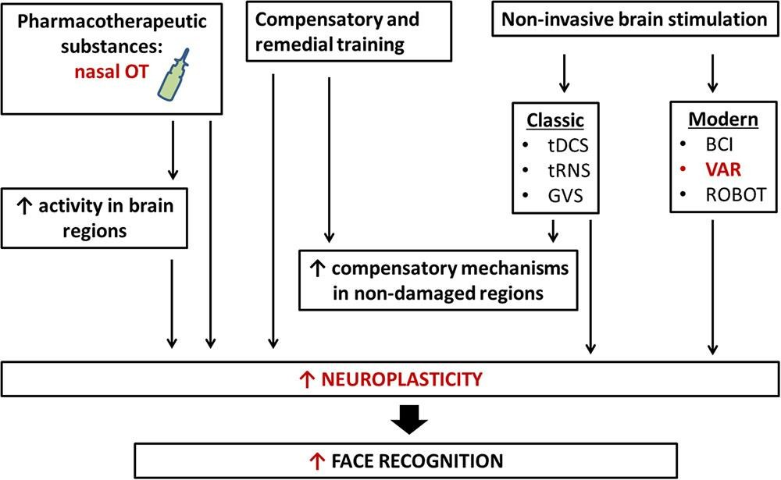

Neurobiological aspect of facial recognition

* + - Despite the benefits, there are four factors that limit the effectiveness of facial recognition technology:

Page17

## 1. Poor Image Quality Limits Facial Recognition's Effectiveness

* + - Image quality affects how well facial-recognition algorithms work. **The image quality of scanning video is quite low compared with that of a digital**

**camera.** Even high-definition video is, at best, 1080p (progressive scan); usually, it is 720p. These values are equivalent to about 2MP and 0.9MP, respectively, while an inexpensive digital camera attains 15MP. The difference is quite noticeable.

## 2. Small Image Sizes Make Facial Recognition More Difficult

* + - When a face-detection algorithm finds a face in an image or in a still from a video capture, the relative size of that face compared with the enrolled image size **affects how well the face will be recognized**. An already small image size, coupled with a target distant from the camera, means that the detected face is only 100 to 200 pixels on a side. Further, having to scan an image for varying face sizes is a processor- intensive activity. Most algorithms allow specification of a face-size range to help eliminate false positives on detection and speed up image processing.

## 3. Different Face Angles Can Throw Off Facial Recognition's Reliability

* + - **The relative angle of the target’s face influences the recognition score profoundly.** When a face is enrolled in the recognition software, usually multiple angles are used (profile, frontal and 45-degree are common). Anything less than a

frontal view affects the algorithm’s capability to generate a template for the face. The more direct the image (both enrolled and probe image) and the higher its resolution, the higher the score of any resulting matches.

* Data Processing and Storage Can Limit Facial Recognition Tech

Even though high-definition video is quite low in resolution when compared with digital camera images, it still occupies significant amounts of disk space. **Processing every frame of video is an enormous undertaking**, so usually only a fraction (10 percent to 25 percent) is actually run through a recognition system. To minimize total processing time, agencies can use clusters of computers. However, adding computers involves considerable data transfer over a network, which can be bound by input- output restrictions, further limiting processing speed.

* + - Ironically, humans are vastly superior to technology when it comes to facial recognition. But humans can only look for a few individuals at a time when watching a source video. A computer can compare many individuals against a database of thousands.

How to Overcome Limits on Facial Recognition Tools

Page18

* + - As technology improves, **higher-definition cameras will become available**. Computer networks will be able to move more data, and processors will work faster. Facial-recognition algorithms will be better able to pick out faces from an image and recognize them in a database of enrolled individuals. The simple mechanisms that defeat today’s algorithms, such as obscuring parts of the face with sunglasses and masks or changing one’s hairstyle, will be easily overcome.
    - An immediate way to overcome many of these limitations is to change how images are captured. Using checkpoints, for example, requires subjects to line up and funnel through a single point. Cameras can then focus on each person closely, yielding far more useful frontal, higher-resolution probe images. However, wide-scale implementation increases the number of cameras required

CONCLUSION AND FUTURE SCOPE

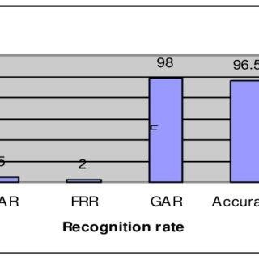

Page19

Face recognition technology has come a long way in the last twenty years. Today, machines are able to automatically verify identity information for secure transactions, for surveillance and security tasks, and for access control to buildings etc. These applications usually work in controlled environments and recognition algorithms can take advantage of the environmental constraints to obtain high recognition accuracy. However, next generation face recognition systems are going to have widespread application in smart environments -- where computers and machines are more like helpful assistants.

To achieve this goal computers must be able to reliably identify nearby people in a manner that fits naturally within the pattern of normal human interactions. They must not require special interactions and must conform to human intuitions about when recognition is likely. This implies that future smart environments should use the same modalities as humans, and have approximately the same limitations. These goals now appear in reach -- however, substantial research remains to be done in making person recognition technology work reliably, in widely varying conditions using information from single or multiple modalities.

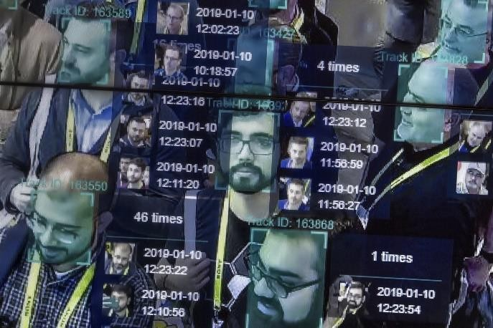

**Reference**

Page20

https:[//www.b](http://www.branded3.com/blog/facial-recognition-in-advertising-time-to-)ra[nded3.com/blog/facial-recognition-in-advertising-time-to-](http://www.branded3.com/blog/facial-recognition-in-advertising-time-to-) panic/

https:[//www.t](http://www.theguardian.com/science/2017/nov/17/killer-robots-un-)h[egu](http://www.theguardian.com/science/2017/nov/17/killer-robots-un-)a[rdian.com/science/2017/nov/17/killer-robots-un-](http://www.theguardian.com/science/2017/nov/17/killer-robots-un-) convention-on-conventional-weapons

<http://fortune.com/2015/03/17/google-facenet-artificial-intelligence/>

https://hospitalitytech.com/3-ways-facial-recognition-tech-can-generate- revenue-hotels-recognition- technology/gy/w=1366&bih=657&dpr=1#imgrc=y3CUslKq6gXmbM:

https://en.wikipedia.org/wiki/Facial_recognition_system https:[//www.scie](http://www.scienceabc.com/innovation/facial-recognition-works.html)nc[eabc.com/innovation/facial-recognition-works.html](http://www.scienceabc.com/innovation/facial-recognition-works.html)



Face recognition showing faces and the amount of times they have appeared